**1.Git-HOL**

**COMMANDS:**

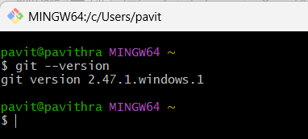**Step 1: Setup your machine with Git Configuration**

**2.To configure user level configuration of user ID and email ID execute :**

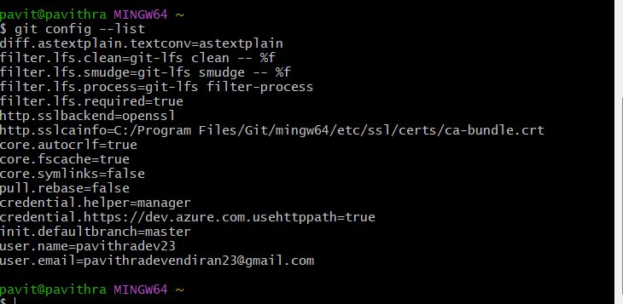

**3.To check if the configuration is properly set, execute the following command.**

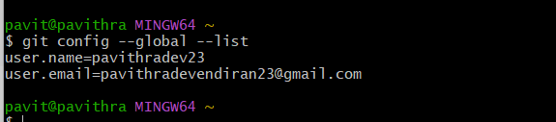

**Step 2: Integrate notepad++.exe to Git and make it a default editor**

1. 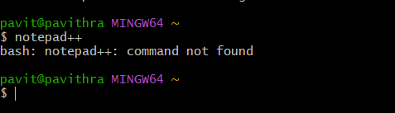**To check, if notepad++.exe execute from Git bash**
2. 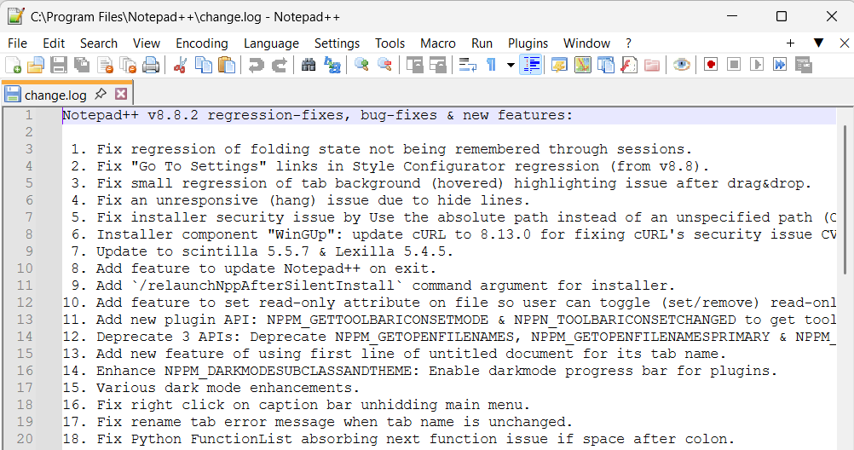**Exit Git bash shell, open bash shell and execute**
3. **To create an alias command for notepad++.exe, execute**

**notepad++**

1. **To configure the editor, execute the command**

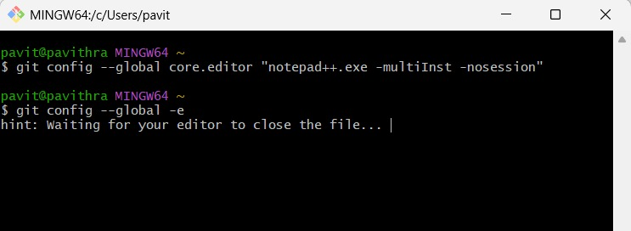

1. **To verify if notepad++ is the default editor, execute the command**

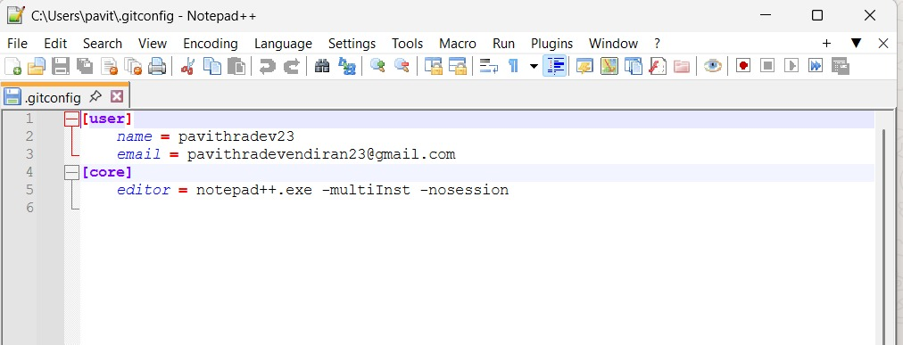

**Step 3: Add a file to source code repository**

**1.Open Git bash shell and create a new project “GitDemo” by executing the command**

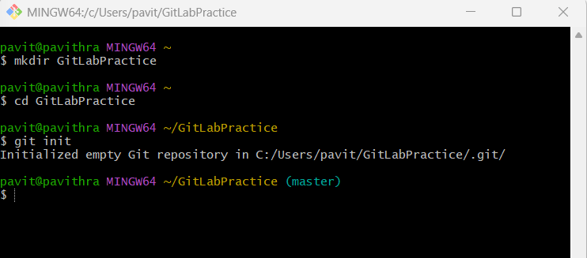

**2.Git bash initializes the “GitDemo” repository. To verify, execute the command**

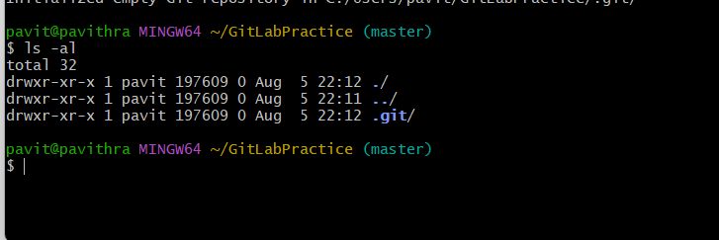

**3.To create a file “welcome.txt” and add content to the file, execute the command**

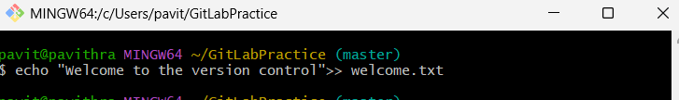

**4.To verify if the file “welcome.txt” is created, execute**

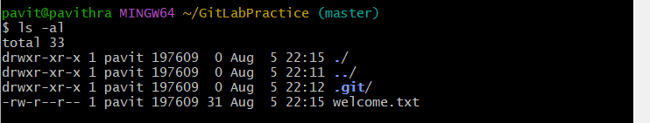

**5.To verify the content, execute the command**

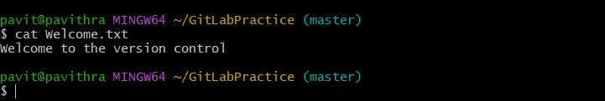

**6.Check the status by executing**

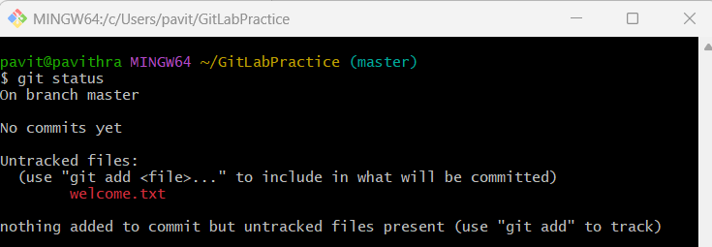

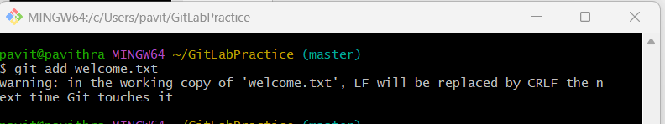**7.To make the file to be tracked by Git repository, execute the command**

**8. To add multi line comments, we are opening default editor to comment. Execute the command**

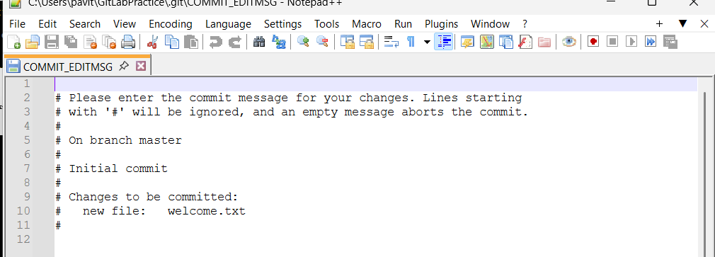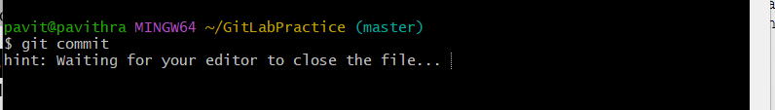

**9.To check if local and “Working Directory” git repository are same, execute git status**

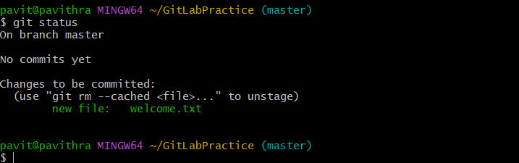

**10.Signup with GitLab and create a remote repository “GitDemo”**

**11.To pull the remote repository, execute**

**git pull origin master**

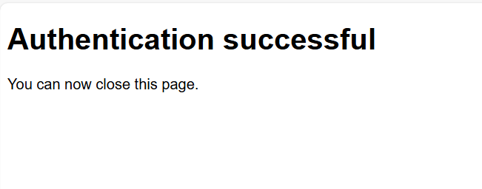

**12.To push the local to remote repository, execute**

**git push origin master**

